|  |  |
| --- | --- |
| API WEATHER PROGRAM  2022 - 2023 | Abstract  This report is a fragment of the assignments that have to be submitted to Prof. Sachin Bhandari for partial fulfilment of Internal Continuous Assessments (ICA), as per the course policy. Our topic for the report is “API Weather Program”, in which we utilised APIs to retrieve weather data of a particular location and save it to a MySQL database and into a CSV file.  Submitted by:  Sanyam Jain (N229) Daksh Gehlot (N230) Gautam Kundalia (N243) |

INDEX

|  |  |  |
| --- | --- | --- |
| S.NO. | CONTENT | PAGE NO. |
| 1 | INTRODUCTION | 2 |
| 2 | PURPOSE AND USE | 3 |
| 3 | MODULES USED | 5 - 6 |
| 4 | THE SOURCE CODE | 7 – 13 |
| 5 | USER MANUAL (PART 1) | 14 – 15 |
| 6 | USER MANUAL (PART 2) | 16 |
| 7 | A LOOK AT THE OUTPUTS | 17 – 20 |
| 8 | MySQL DATABASE | 21 |
| 9 | DATA OUTPUT IN CSV | 22 |
| 10 | WEB REFERENCES | 23 |

|  |  |  |  |
| --- | --- | --- | --- |
|  |  | |  |
| INTRODUCTION | | | |
| API An API, which stands for Application Programming Interface, is a software intermediary which allows two application to communicate with each other. Each time you use an app like Instagram, send an instant message, or check the weather on your phone, you’re using an API.  To simplify, an API delivers a user response to a system and sends the system's response back to a user. It enables this process to be completed efficiently and without any huge delays. Modern APIs adhere to standards (like HTTP) that are developer friendly, easily accessible and broadly understood, and are used by major companies like Google, eBay, Amazon and Expedia. | | A website, which itself uses an API to complete requests, is displaying what an API is. | |
|  | |

|  |  |  |  |  |
| --- | --- | --- | --- | --- |
|  | | | | |
|  |  | PURPOSE AND USE When you use an application on your mobile phone, the application connects to the Internet and sends data to a server. The server then retrieves that data, interprets it, performs the necessary actions and sends it back to your phone. The application then interprets that data and presents you with the information you wanted in a readable way. This is what an API is - all of this happens via API.  Imagine a waiter at a café. You want to order something from the menu and the kitchen has the cooks that will provide you with your favorite meal. You need a link to communicate your order with the kitchen and deliver your food back to your table. That’s where the waiter – or the API – enters the picture. |  |  |

### PROBLEM STATEMENT AND SOLUTION

**Problem Statement:**

It is only natural that sometimes a person might want to find the weather of a particular location. This area can be anywhere around the globe – not only in the country. Also, they might want the weather data to be saved so that they can refer to it later.

**Proposed Solution:**

The program that we implemented uses an API to retrieve weather data for any particular location. On running the program, the user is asked if they want the current weather data, or data for yesterday or tomorrow. The respective info will be retrieved when the user selects the option. After that, they will be given a choice to see a weather forecast graph for the next 7 days. The graph can be viewed in Celsius as well as Fahrenheit.

The weather data originally retrieved is saved in a MySQL database as well as in a CSV file. The user is given an option to retrieve this data if they would like to go through the history.

**Hardware Requirements:**

Intel i3 3rd gen or higher or AMD Ryzen 3 1600 or higher

**Software Requirements:**

Windows 7, 8, 10, 11 (32 or 64 bit), Visual Studio Code / PyCharm, API Key, MySQL database

### MODULES USED

1. **Requests module**: The requests module allows you to send HTTP requests using Python. The HTTP request returns a [Response Object](https://www.w3schools.com/python/ref_requests_response.asp) with all the response data (content, encoding, status, etc).
2. **datetime module**: In Python, date and time are not a data type of its own, but a module named datetime can be imported to work with the date as well as time. It also combines date and time information.
3. **time module**: This module provides various time-related functions, which gives us many ways of representing time in code, such as objects, numbers, and strings. It refers to the time independent of the day (hour, minute, second, microsecond).
4. **JSON module:** JavaScript Object Notation (JSON) is a standardized format commonly used to transfer data as text that can be sent over a network. It’s used by lots of APIs and databases, and it’s easy for both humans and machines to read. JSON represents objects as name/value pairs, just like a Python dictionary. It parses return objects in human readable form.
5. **matplotlib.pyplot**: Matploitlib is a Python Library used for plotting graphs, this python library provides with objected-oriented APIs for integrating plots into applications. **matplotlib.pyplot** is a plotting library used for 2D graphics in python.
6. **geocoder module**: It allows the user to access the coordinates of a location using its name, and vice versa. It is helpful in identifying and determining the exact location of a place, with good accuracy.
7. **mysql.connector:** Python needs a MySQL driver to access the MySQL database. This library provides Python with the access to MySQL to execute queries. Queries can be executed to create, read, update and delete data.
8. **csv:** The csv module implements classes to read and write tabular data in CSV format. It allows programmers to write data in the format preferred by Excel or read data from a file which was generated by Excel, without knowing the precise details of the CSV format used by Excel.
9. **numpy:** NumPy is a general-purpose array-processing package. It provides a high-performance multidimensional array object, and tools for working with these arrays. It is the fundamental package for scientific computing with Python. It is open-source software.

### THE SOURCE CODE

Below starts the source code of our API program:

#A program by Sanyam Jain (N229), Daksh Gehlot (N230) and Gautam Kundalia (N243)

**import** requests

**import** json

**import** time

**import** datetime

**import** geocoder

**import** matplotlib**.**pyplot **as** plt

**import** mysql**.**connector **as** mcon

**import** csv

**import** numpy **as** np

**print()**

**print(**"Request pulled on:"**)**

**print(**time**.**asctime**())**

a **=** datetime**.**date**.**today**()**

pswm **=** **input(**"PLease enter your mysql password for connectivity: "**)**

mcon**=**mcon**.**connect**(**host**=**'localhost'**,** user**=**'root'**,** passwd**=**pswm**)**

cursor**=**mcon**.**cursor**()**

x**=input(**"Do you want the database to be created automatically (Y/N)? "**)**

**while** **True:**

**if** x **in** **(**"Y"**,**"y"**):**

**while** **True:**

datb **=** **input(**"Please enter the preferred name of the database in which the table should exist: "**)**

h **=** **input(**"Are you sure that the above entered info is correct? (Y/N): "**)**

**if** h **in** **(**'Y'**,**'y'**):**

**print(**'Good job, moving on...'**)**

**print()**

**break**

**elif** h **in** **(**'N'**,** 'n'**):**

**print(**"Give it another try!"**)**

**else:**

**print(**"Invalid choice, try again!"**)**

**print()**

datn**=**datb**.**replace**(**" "**,** "_"**)**

cursor**.**execute**(**'create database {}'**.format(**datn**))**

cursor**.**execute**(**'use {}'**.format(**datn**))**

**elif** x **in** **(**"N"**,** "n"**):**

**while** **True:**

datb**=input(**"Enter the name of an existing database in which you want the data to be saved: "**)**

h **=** **input(**"Are you sure that the above entered info is correct? (Y/N): "**)**

**if** h **in** **(**'Y'**,**'y'**):**

**print(**'Good job, moving on...'**)**

**print()**

**break**

**elif** h **in** **(**'N'**,** 'n'**):**

**print(**"Give it another try!"**)**

**else:**

**print(**"Invalid choice,try again!"**)**

**print()**

datn**=**datb**.**replace**(**" "**,** "_"**)**

cursor**.**execute**(**'use {}'**.format(**datn**))**

**else:**

**print(**"Invalid choice, try again!"**)**

**break**

lapi **=** '33b327f0ca624ce089892bd897843bb0'

wapi **=** '16ff12c7ba9d5ea26a00939999d81ee2'

cursor**.**execute**(**'show tables;'**)**

st**=**cursor**.**fetchall**()**

**while** **True:**

**if** st **==** **[(**'weather_report'**,)]:**

**print(**"The table already exists, nice!"**)**

s **=** 0

**break**

**else:**

**print(**"Would you like the MySQL table to be created automatically by the program?"**)**

**print(**"Note: If you decline, no values will be written in the database!"**)**

x**=input(**"Enter 'Y/y' to accept, or 'N/n' to decline: "**)**

**if** x **in** **(**"Y"**,**"y"**):**

cursor**.**execute**(**'''create table weather_report(

Date varchar(10) not null not null,

Current_Temperature_CELSIUS decimal(4,2) not null,

Feels_Like_CELSIUS decimal(4,2) not null,

Humidity int(2) not null,

Time varchar(5) not null,

City varchar(15) not null)'''**)**

s **=** 0

**print()**

**break**

**elif** x**==**"N" **or** x**==**"n"**:**

**print(**"The table doesn't exist, no values will be written in database!!"**)**

s **=** 1

**break**

**else:**

**print(**"Please enter a valid choice"**)**

cursor**.**reset**()**

**if** s **==** 0**:**

**if** mcon**.**is_connected**():**

**print(**'Database Connection Succesful'**)**

**print()**

h **=** **input(**"Do you want to know the description of the table (Y/N): "**)**

**print()**

**if** h **in** **(**'Y'**,** 'y'**):**

cursor**.**execute**(**"Desc weather_report"**)**

**print(**'Description of Database is'**)**

**print()**

**for** x **in** cursor**.**fetchall**():**

**print(**x**)**

**else:**

**print(**'Database Connection Error'**)**

**def** coord**(**city**):**

**global** result

result **=** geocoder**.**opencage**(**city**,** key**=**lapi**)**

**print(**""**)**

#print(result)

**global** lat

**global** lon

**try:**

lat**,** lon **=** result**.**latlng**[**0**],** result**.**latlng**[**1**]**

**return** lat**,** lon

**except** **TypeError:**

**print(**"Enter a valid city!"**)**

**def** cel**(**val**):**

cels **=** **round((**val **-** 273.15**),** 2**)**

**return** cels

**def** far**(**val**):**

faren **=** **round((**val **\*** **(**9**/**5**)** **-** 459.67**),** 2**)**

**return** faren

**def** curr_weather**():**

l **=** 3

**while** l **<** 8**:**

**global** city

city **=** **str.**capitalize**(input(**"Enter City name: "**))**

coord**(**city**)**

**if** result**.**latlng **==** **None:**

**print(**"Invalid City name, try again..."**)**

**else:**

resp **=** requests**.**get**(**'https://api.openweathermap.org/data/2.5/weather?q={}&appid={}'

**.format(**city**,** wapi**))**

**if** resp**.**status_code **==** 200**:**

t **=** json**.**loads**(**resp**.**text**)**

**print(**"The coordinates of entered location are: \n"**,** coord**(**city**))**

**print(**"-------------------------"**)**

**print()**

**print(**":::::The Current Weather of {} is:::::"**.format(**city**))**

**global** temp

**global** hum

**global** feel

hum **=** t**[**'main'**][**'humidity'**]**

temp**=** **(**cel**(**t**[**'main'**][**'temp'**]),**far**(**t**[**'main'**][**'temp'**]))**

feel **=** **(**cel**(**t**[**'main'**][**'feels_like'**]),** far**(**t**[**'main'**][**'feels_like'**]))**

**print()**

**print(**"■ Today's average temperature:"**,** temp**[**0**],** '℃'**,** 'or'**,** temp**[**1**],** '℉'**)**

**print(**'■ Feels Like:'**,** feel**[**0**],** '℃'**,** 'or'**,** feel**[**1**],** '℉'**)**

**print(**'■ Humidity:'**,** hum**,** '%'**)**

l **+=** 2

**break**

**elif** resp**.**status_code **==** 400**:**

**print(**"Server error \n trying again in"**,** l**,** "seconds..."**)**

time**.**sleep**(**l**)**

l **+=** 1

**if** l **==** 7**:**

**print(**"Too many errors, check your internet connection and arguments given and try again"**)**

**break**

**def** yest_weather**():**

l **=** 3

**while** l **<** 8**:**

**global** city

city **=** **str.**capitalize**(input(**"Enter City name: "**))**

dt **=** **int((**time**.**time**())** **-** 86400**)**

coord**(**city**)**

**if** result**.**latlng **==** **None:**

**print(**"Invalid City name, try again..."**)**

**else:**

resp **=** requests**.**get**(**'https://api.openweathermap.org/data/2.5/onecall/timemachine?lat={}\

&lon={}&dt={}&appid={}'**.format(**lat**,** lon**,** dt**,** wapi**))**

**if** resp**.**status_code **==** 200**:**

t **=** json**.**loads**(**resp**.**text**)**

**print(**"The coordinates of entered location are: \n"**,** coord**(**city**))**

**print(**"-------------------------"**)**

**print()**

**print(**":::::The Yesterday's Weather of {} is:::::"**.format(**city**))**

**global** temp

**global** feel

**global** hum

temp **=** **(**cel**(**t**[**'current'**][**'temp'**]),** far**(**t**[**'current'**][**'temp'**]))**

feel **=** **(**cel**(**t**[**'current'**][**'feels_like'**]),** far**(**t**[**'current'**][**'feels_like'**]))**

hum **=** t**[**'current'**][**'humidity'**]**

**print()**

**print(**"■ Yesterday's weather: "**,** temp**[**0**],** '℃'**,** 'or'**,** temp**[**1**],** '℉'**)**

**print(**'■ Felt Like:'**,** feel**[**0**],** '℃'**,** 'or'**,** feel**[**1**],** '℉'**)**

**print(**'■ Humidity:'**,** hum**,** '%'**)**

l **+=** 2

**break**

**elif** resp**.**status_code **==** 400**:**

**print(**"Server error \n trying again in"**,** l**,** "seconds..."**)**

time**.**sleep**(**l**)**

l **+=** 1

**if** l **==** 7**:**

**print(**"Too many errors, check your internet connection and arguments given and try again"**)**

**break**

**def** tomm_weather**():**

l **=** 3

**while** l **<** 8**:**

**global** city

city **=** **str.**capitalize**(input(**"Enter City name: "**))**

coord**(**city**)**

**if** result**.**latlng **==** **None:**

**print(**"Invalid City name, try again..."**)**

**else:**

resp **=** requests**.**get**(**'https://api.openweathermap.org/data/2.5/onecall?lat={}&lon={}&appid={}'

**.format(**lat**,** lon**,** wapi**))**

**if** resp**.**status_code **==** 200**:**

t **=** json**.**loads**(**resp**.**text**)**

**print(**"The coordinates of entered location are: \n"**,** coord**(**city**))**

**print(**"-------------------------"**)**

**print()**

**print(**":::::The Weather Forecast of {} is:::::"**.format(**city**))**

**print()**

**global** temp

**global** feel

**global** hum

temp **=** **(**cel**(**t**[**'daily'**][**0**][**'temp'**][**'day'**]),** far**(**t**[**'daily'**][**1**][**'temp'**][**'day'**]))**

feel **=** **(**cel**(**t**[**'daily'**][**0**][**'feels_like'**][**'day'**]),** far**(**t**[**'daily'**][**1**][**'feels_like'**][**'day'**]))**

hum **=** t**[**'daily'**][**0**][**'humidity'**]**

**print(**"■ Tomorrow's weather will be: "**,** temp**[**0**],** '℃'**,** 'or'**,** temp**[**1**],** '℉'**)**

**print(**"■ It will feel like: "**,** feel**[**0**],** '℃'**,** 'or'**,** feel**[**1**],** '℉'**)**

**print(**"■ Humidity will be: "**,** hum**,** '%'**)**

l **+=** 2

**break**

**elif** resp**.**status_code **==** 400**:**

**print(**"Server error \n trying again in"**,** l**,** "seconds..."**)**

time**.**sleep**(**l**)**

l **+=** 1

**if** l **==** 7**:**

**print(**"Too many errors, check your internet connection and arguments given and try again"**)**

**break**

**def** graph**():**

**while** **True:**

g **=** **input(**"Do you want forecast graph for next 7 days? (Y/N): "**)**

**if** g **in** **(**'Y'**,** 'y'**):**

days **=** **[]**

temps **=** **[]**

mintemps **=** **[]**

maxtemps **=** **[]**

info **=** requests**.**get**(**"https://api.openweathermap.org/data/2.5/onecall?lat={}&lon={}&appid={}"

**.format(**lat**,** lon**,** wapi**))**

info **=** info**.**text

data **=** json**.**loads**(**info**)**

**print(**"Enter the unit you want the graph in \n▶for CELSIUS, enter C/c. \n▶for FAHRENHEIT,\

enter F/f."**)**

**while** **True:**

unit **=** **input(**"Enter your choice (C/F): "**)**

**if** unit **in** **(**'C'**,** 'c'**):**

plt**.**ylabel**(**"Temperature (in celsius)"**)**

**break**

**elif** unit **in** **(**'F'**,** 'f'**):**

plt**.**ylabel**(**"Temperature (in fahrenheit)"**)**

**break**

**else:**

**print(**"Invalid choice try again...."**)**

**print()**

**for** i **in** **range(**7**):**

day **=** datetime**.**datetime**.**fromtimestamp**(**data**[**"daily"**][**i**][**'dt'**]).**strftime**(**"%A"**)**

**if** unit **in** **(**'C'**,** 'c'**):**

temp **=** cel**(**data**[**'daily'**][**i**][**'temp'**][**'day'**])**

mintemp **=** cel**(**data**[**'daily'**][**i**][**'temp'**][**'min'**])**

maxtemp **=** cel**(**data**[**'daily'**][**i**][**'temp'**][**'max'**])**

**elif** unit **in** **(**'F'**,** 'f'**):**

temp **=** far**(**data**[**'daily'**][**i**][**'temp'**][**'day'**])**

mintemp **=** far**(**data**[**'daily'**][**i**][**'temp'**][**'min'**])**

maxtemp **=** far**(**data**[**'daily'**][**i**][**'temp'**][**'max'**])**

days**.**append**(**day**)**

temps**.**append**(**temp**)**

maxtemps**.**append**(**maxtemp**)**

mintemps**.**append**(**mintemp**)**

**print(**"► Here is the graph:"**)**

plt**.**xlabel**(**"Days"**)**

plt**.**plot**(**days**,** temps**,** 'c'**,** label**=**'Average temperature'**,** marker**=**'o'**)**

plt**.**plot**(**days**,** maxtemps**,** 'r'**,** label**=**'Maximum temperature'**,** marker**=**'o'**)**

plt**.**plot**(**days**,** mintemps**,** 'b'**,** label**=**'Minimum temperature'**,** marker**=**'o'**)**

plt**.**title**(**"The weather forecast of {} for next 7 days"**.format(**city**))**

plt**.**legend**()**

plt**.**show**()**

**print()**

**break**

**elif** g **in** **(**"n"**,** "N"**):**

**print()**

**print(**"Okay"**)**

**print()**

**break**

**else:**

**print(**"Invalid Choice, Try again..."**)**

**print()**

#Display Data From Database

**def** data_from_database**():**

cursor**.**execute**(**'Select * from weather_report order by Time desc'**)**

n**=int(input(**'Enter the number of past records you want to see: '**))**

**print()**

data**=**cursor**.**fetchmany**(**n**)**

count**=**cursor**.**rowcount

**print(**data**)**

**print()**

**print(**'No of Records: '**,**count**)**

cursor**.**reset**()**

**print()**

**print()**

# Display Data From Database by city

**def** data_from_city**():**

a**=input(**'Which city\'s record do you want to see? '**)**

cursor**.**execute**(**'Select * from weather_report where city="{}"'**.format(**a**))**

data**=**cursor**.**fetchall**()**

count**=**cursor**.**rowcount

**print()**

**print(**data**)**

**print()**

**print(**'No of Records: '**,**count**)**

**print()**

cursor**.**reset**()**

**print()**

# Dislplay Highest Temperature in record

**def** highest_Temp**():**

cursor**.**execute**(**'Select * from weather_report order by Current_Temperature_CELSIUS DESC'**)**

data**=**cursor**.**fetchmany**(**1**)**

count**=**cursor**.**rowcount

**print(**data**)**

**print()**

**print(**'No of Records: '**,**count**)**

cursor**.**reset**()**

**print()**

**print()**

# No of Data according to cities

**def** no_of_cities_data**():**

cursor**.**execute**(**'Select city,count(*) from weather_report group by City'**)**

data**=**cursor**.**fetchall**()**

count**=**cursor**.**rowcount

**print(**data**)**

**print()**

**print(**'No of Records: '**,**count**)**

cursor**.**reset**()**

**print()**

y**=**time**.**strftime**(**'%H:%M'**)**

**def** insert**():**

cursor**.**execute**(**"INSERT INTO weather_report(Date, Current_Temperature_CELSIUS, Feels_Like_CELSIUS,\

Humidity, Time, City) VALUES('{}',{},{},{},'{}','{}')"

**.format(**tp1**,** temp**[**0**],** feel**[**0**],** hum**,** y**,**city**.**upper**()))**

mcon**.**commit**()**

**print(**'(Data successfully saved in the database)'**)**

cursor**.**reset**()**

**while** **True:**

**print(**"What information do you want? \n● 1.Current weather \n● 2.Yesterday's weather\

\n● 3.Tomorrow's weather"**)**

**print()**

op **=** **input(**"Enter your choice (1, 2 or 3): "**)**

**if** op **==** '1'**:**

**print(**"You chose for today's weather..."**)**

#global tp1

tp1 **=** a**.**strftime**(**"%d-%m-%y"**)**

**print(**"◖Today's date is"**,** tp1**,** "◗"**)**

curr_weather**()**

**print()**

**if** s **==** 0**:**

insert**()**

graph**()**

**break**

**elif** op **==** '2'**:**

**print(**"You chose for yesterday's weather..."**)**

#global tp1

tp2 **=** datetime**.**date**.**today**()** **-** datetime**.**timedelta**(**days**=**1**)**

tp1 **=** tp2**.**strftime**(**"%d-%m-%Y"**)**

**print(**"◖Yesterday's date was:"**,** tp1**,** '◗'**)**

yest_weather**()**

**print()**

**if** s **==** 0**:**

insert**()**

graph**()**

**break**

**elif** op **==** '3'**:**

#global tp1

tp4**=**datetime**.**date**.**today**()** **+** datetime**.**timedelta**(**days**=**1**)**

tp1 **=** tp4**.**strftime**(**"%d-%m-%Y"**)**

**print(**"You chose for tomorrow's weather..."**)**

**print(**"◖The date tomorrow is:"**,** tp1**,** '◗'**)**

tomm_weather**()**

**print()**

**if** s **==** 0**:**

insert**()**

graph**()**

**break**

**else:**

**print(**"INVALID CHOICE, Try Again..."**)**

**if** s **==** 0**:**

**while** **True:**

**print(**'''If you want to see data from database, press 1

If you want to see data by city, press 2

If you want to see the number of records for each city, press 3

If you want to see highest temperature in the records, press 4

To end program, press 5'''**)**

x**=int(input(**'Enter Your Choice: '**))**

**if** x**==**1**:**

**print()**

**print(**"The order of the columns is"**)**

**print(**'Date,'**,** 'Current_Temperature_CELSIUS,'**,** 'Feels_Like_CELSIUS,'**,**'Humidity,'**,**\

'Time,'**,** 'City'**)**

data_from_database**()**

**elif** x**==**2**:**

data_from_city**()**

**elif** x**==**3**:**

no_of_cities_data**()**

**elif** x**==**4**:**

highest_Temp**()**

**elif** x**==**5**:**

**print(**'Thank You'**)**

**break**

 **else:**

**print(**'Enter Valid Choice'**)**

mcon**.**close**()**

USER MANUAL

(FOR AUTOMATIC CREATION OF THE DATABASE AND THE TABLE)

The API Weather Code that we have built, includes a function to automatically create a database and the table in it in MySQL to store the data retrieved by the program, provided that the user gives the correct password to their MySQL databases. However, the users have the option to decline the requests and create a database and table on their own (please see page number 17).

Below is the guide for automatic creation of the database and table:

1. On running the code, users will be able to see the current data and time, and a request asking them to enter their MySQL password. Be sure to enter the correct one. After that, they will be asked whether they want the database to be created automatically or not. Press “Y/y” for yes and “N/n” for no, and then confirm the entered info:

1. Now the user has the choice to either allow the program to create a table automatically or decline it. If a table is not present, then the data won’t be saved. On choosing “Yes”, the table would be created, and a message will be displayed confirming the

connection to the database. Users also have the capacity to view the description of the table if they wish to do so:

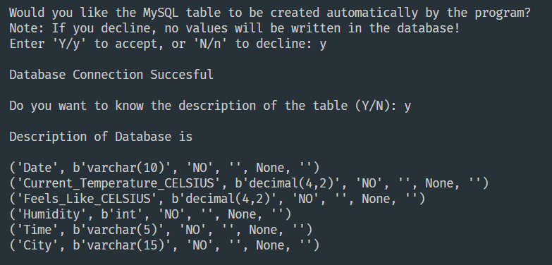

In case they decide to create the database and the table manually, that is, they choose “No” in either or both of the steps 1 and 2, the instructions given on the next page may be followed.

**NOTE:** You also need a stable internet connection for this code to work.

### USER MANUAL

(FOR MANUALLY CREATING THE DATABASE AND THE TABLE)

There are certain steps that we must know before going further. First of them is to create a MySQL database to store the records.

1. Open MySQL.
2. Create a database by entering the code

“create database python_project;” (or any name of your choice).

1. Now change the database to this newly created one by typing “python_project;”.
2. Create the table “weather_report” by entering the below queries:

create table weather_report(

Date varchar(10) not null not null,

Current_Temperature_CELSIUS decimal(4,2) not null,

Feels_Like_CELSIUS decimal(4,2) not null,

Humidity int(2) not null,

Time varchar(5) not null,

City varchar(15) not null);

1. Your MySQL database is now ready.

**NOTE:** You also need a stable internet connection for this code to work.

### OUTPUTS AND RESULTS

The source code was quite long, wasn’t it? Now let’s see the outputs.

1. After successfully connecting the python code to MySQL database, the program will give the user 3 choices, asking them if they want the weather for today, yesterday, or tomorrow and will save the data retrieved from the API to MySQL database as well as in a CSV file.

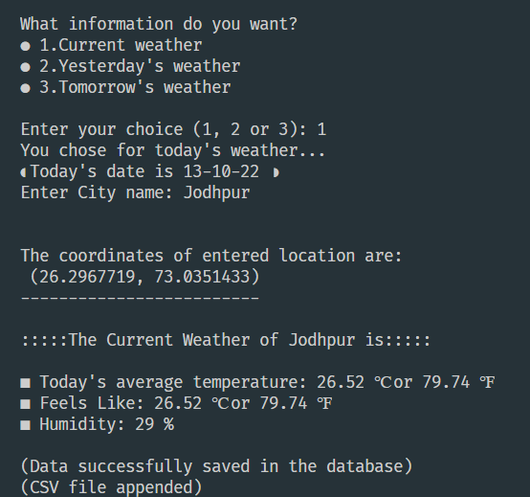

1. Now the user will be asked if they want to see the forecast graph of the next 7 days (for the given city) and shall receive the said information by entering “Y” or “y”. For the graph, we used matplotlib and passed numpy arrays into the plot function of the package:

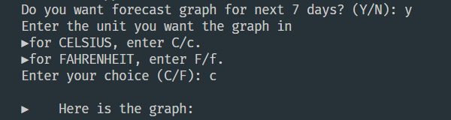

1. The users may want to check the past records stored in MySQL databases. For that, they will be presented with 5 different choices, i.e., 5 different ways to access the records, depending upon the user. If they don’t want to do so, they can end the program immediately by pressing number 5. (Please see the next page.)

**Choice 1 will let the user access desired number of latest past records.**

**Choice 2 will enable the user to see the data of a specific city.**

**Choice 3 allows the user to see the number of records for all cities that have been entered by all different users.**

**Choice 4 will display the record containing the highest temperature out of all the cities.**

**Choice 5 will end the program and the user will receive a gentle “Thank You”.**

Note that the choices will get displayed again and again after selecting each choice, except choice 5, for which the program will end immediately.

The screenshots for the outputs have been attached on the next page.

### 

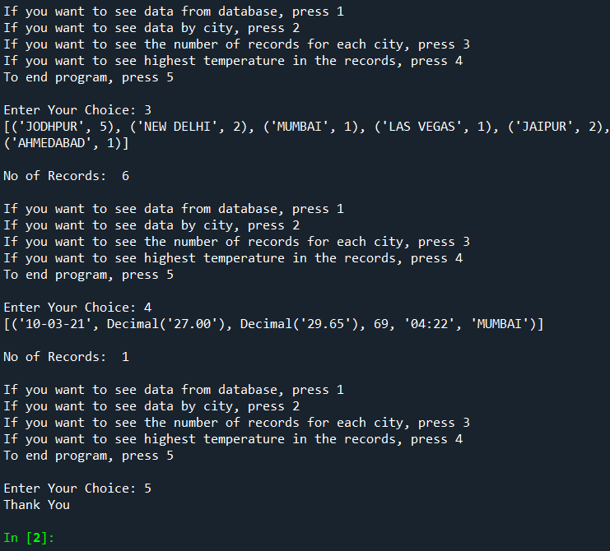

MySQL DATABASE

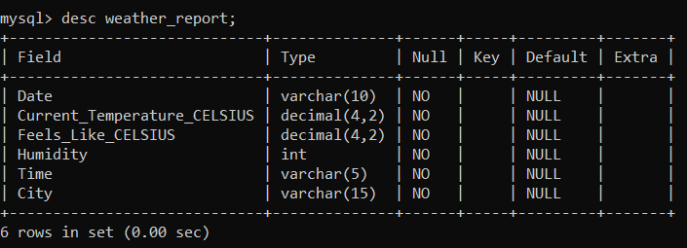The description of the table created is presented in this screenshot:

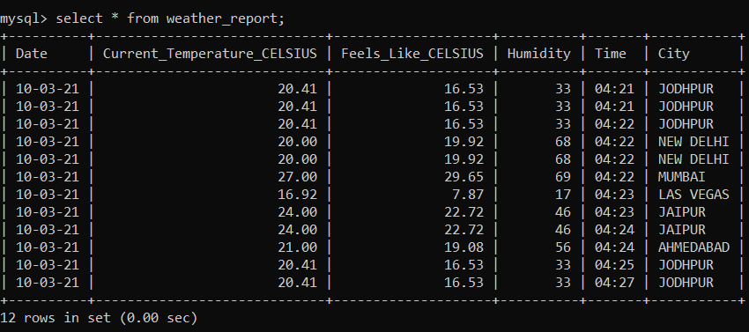One can see that the data retrieved by the Python-API program is stored in the table created in MySQL:

DATA OUTPUT IN CSV

### The data returned by the API will also be appended in a CSV file. Here is the screenshot of the output obtained in the csv:

### WEB REFERENCES

We used API from the following services:

* Weather API via:

<https://openweathermap.org/api>/

* API used for coordinates via:

<https://opencagedata.com/>

* Other Useful free websites that helped us overcome the errors

1. <https://www.mulesoft.com/>
2. <https://www.infoworld.com/>
3. <https://pypi.org/>
4. <https://www.w3schools.com/>
5. <https://www.geeksforgeeks.org/>
6. <https://realpython.com/>
7. <https://stackoverflow.com/>

THANK YOU!

A PROGRAM BY SANYAM JAIN (N229), DAKSH GEHLOT (N230) AND GAUTAM KUNDALIA (N243).